SREE NARAYANA TRAINING COLLEGE
You can’t retire from being great
organizes the
FAREWELL GATHERING
of
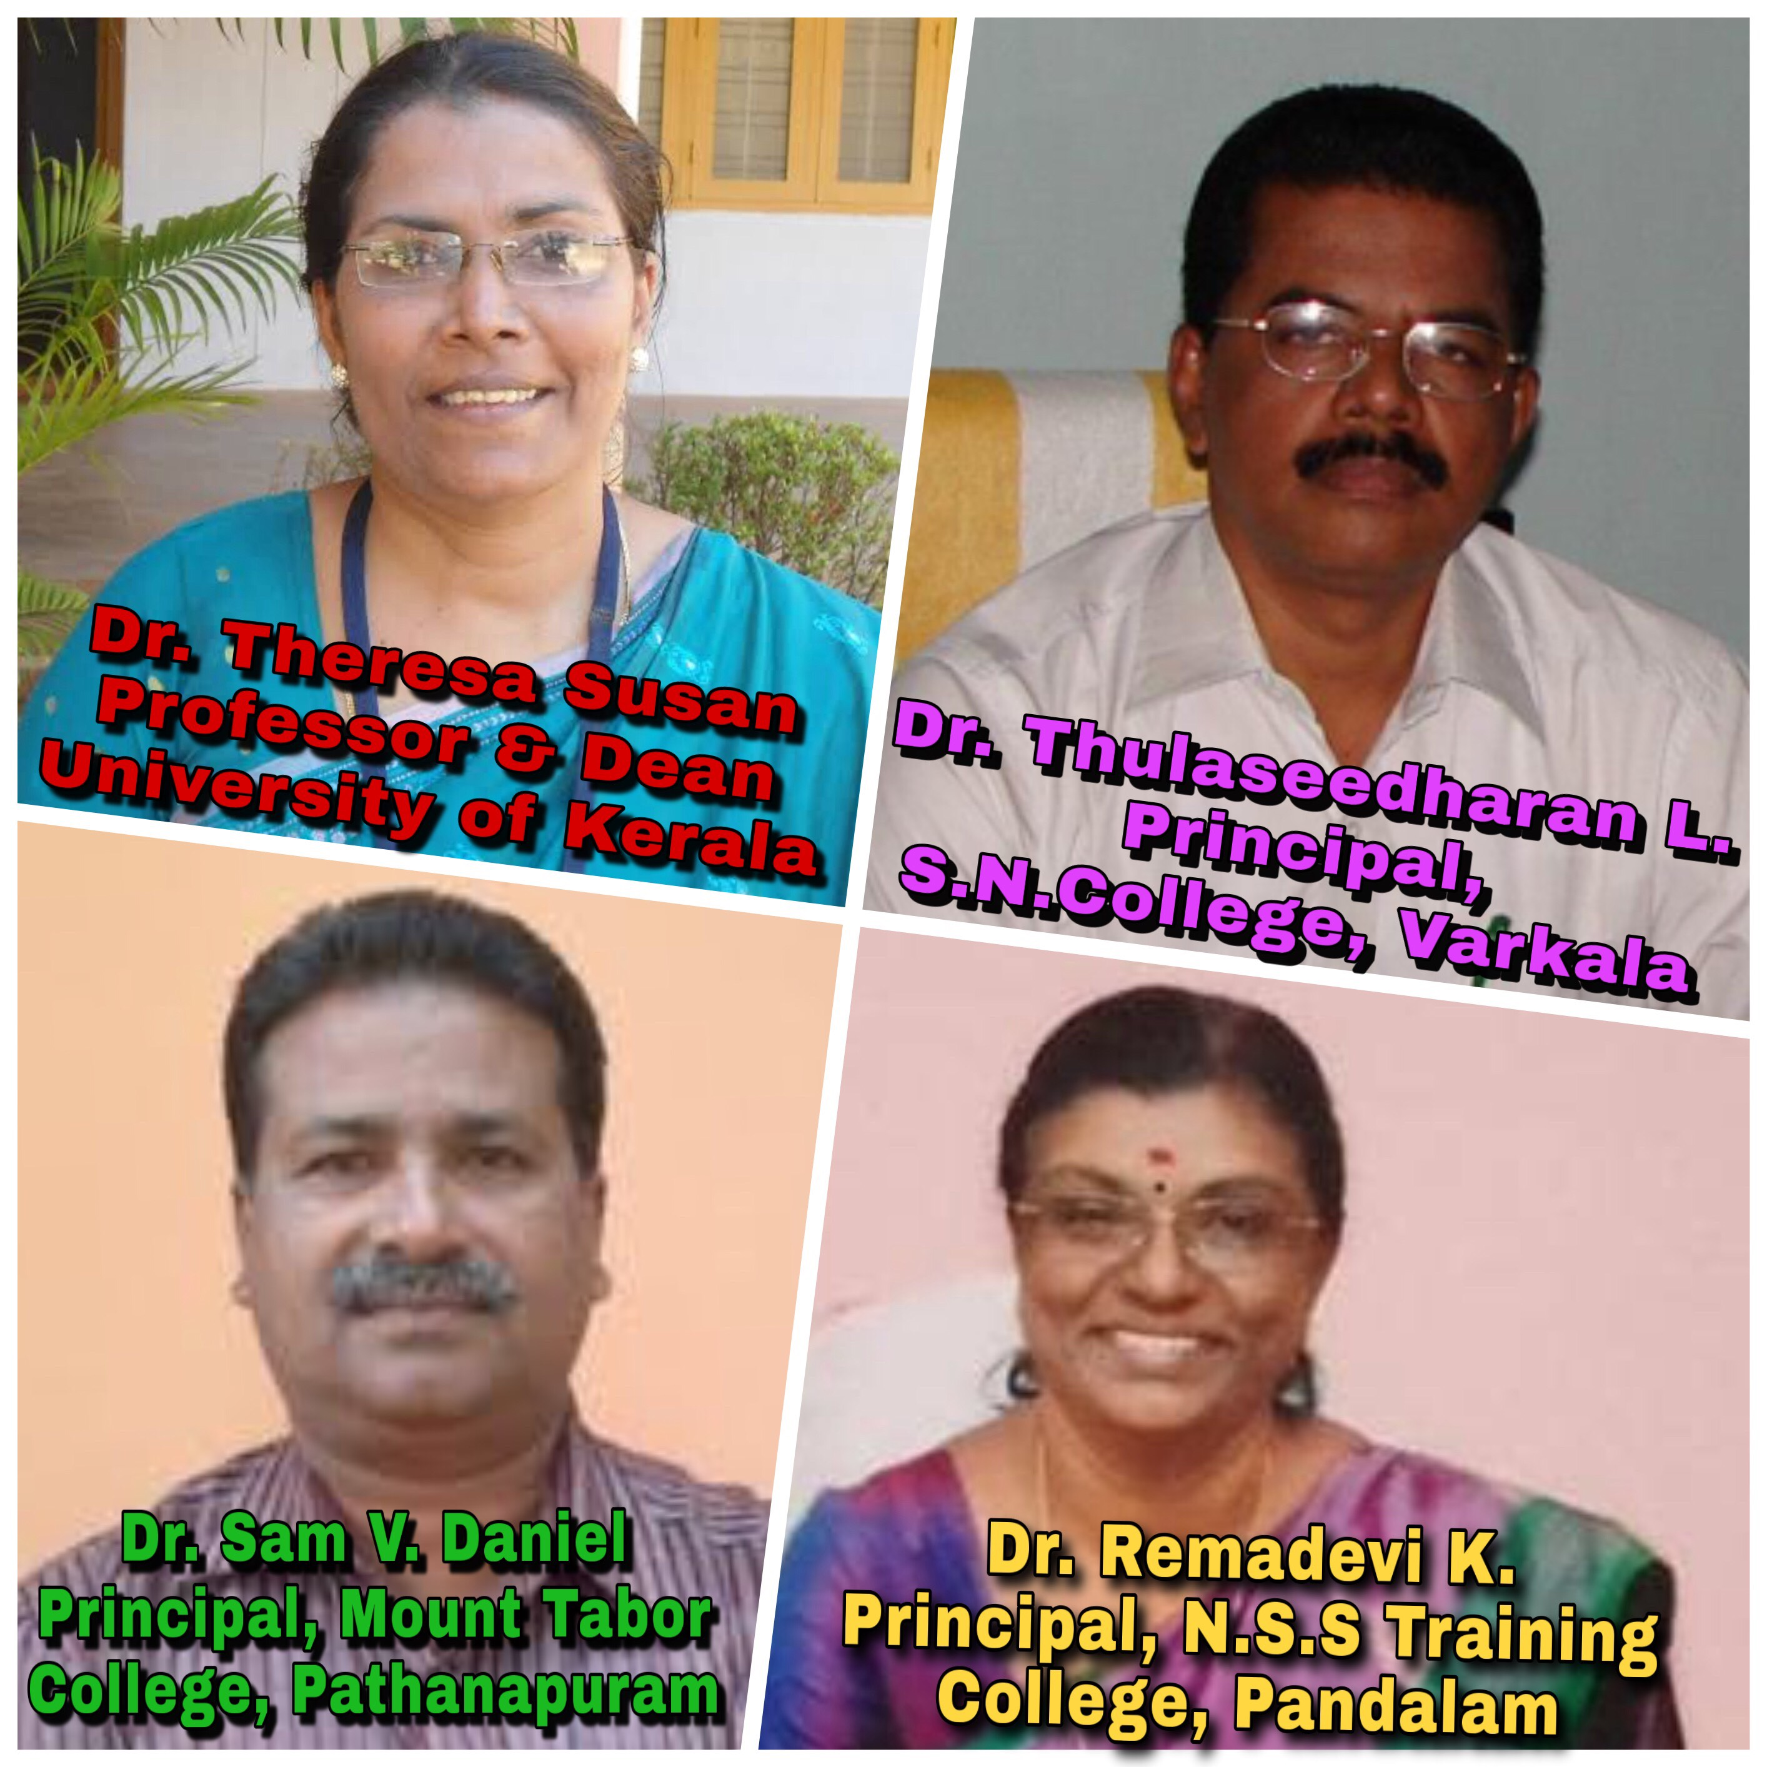
On 27-03-2019 at 02.30 p.m.
Venue: College Auditorium
PROGRAMME SCHEDULE
27/03/2019, Wednesday
Prayer : College Choir
Welcome Speech : Dr. Sheeba P.
(Associate Professor, SNTC)
Presidential Address: Dr. Rany S.
(Principal, SNTC)
Farewell Message : Dr. M. Jayaprakash
(Former DCDC,
University of Kerala)
Felicitations
Reply Speech : Dr. Theresa Susan A.
(Dean and Former Head of the Department of Education,
University of Kerala)
Dr. Thulaseedharan L.
(Principal, S.N. College, Varkala)
Dr. Sam V. Daniel
(Principal, Mount Tabor Training
College, Pathanapuram)
Dr. Remadevi K.
(Principal, N.S.S. Training College,
Pandalam)
Vote of Thanks : Dr. Pramod G. Nair
(Assistant Professor, SNTC)

